REPORT Z.

PARAMETERS NUM1 TYPE I DEFAULT 10. "cannot give value for parameter

PARAMETERS NUM2 TYPE I.

DATA RES TYPE I.

RES = NUM1 + NUM2.

WRITE: 'The Addition of ', Num1, 'And', Num2, 'is', Res.

In the above activated program, Goto -> Text Elements

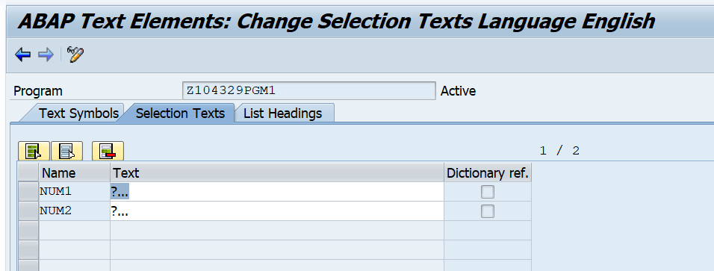

Enter the text against the parameter names as shown below. Activate the Text Element.

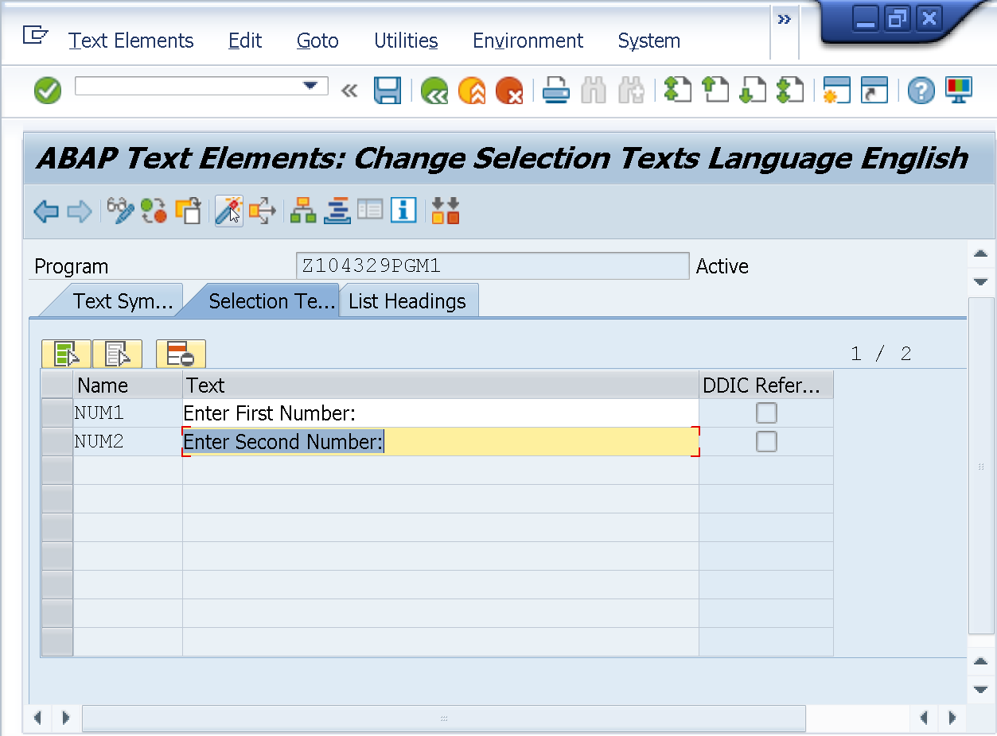

Execute the program.

Observe the Selection Text.

